**UCF Mobile Training Guide 2021-2022**

A comprehensive guide on how to work on the UCF Mobile App.



1. **Access GitHub**

To better organize and simplify our development phase, our team utilizes github to contain, upload, and share our work. You can access the github [here](https://github.com/mikojimnz/DIG4104C) - <https://github.com/mikojimnz/DIG4104C>.

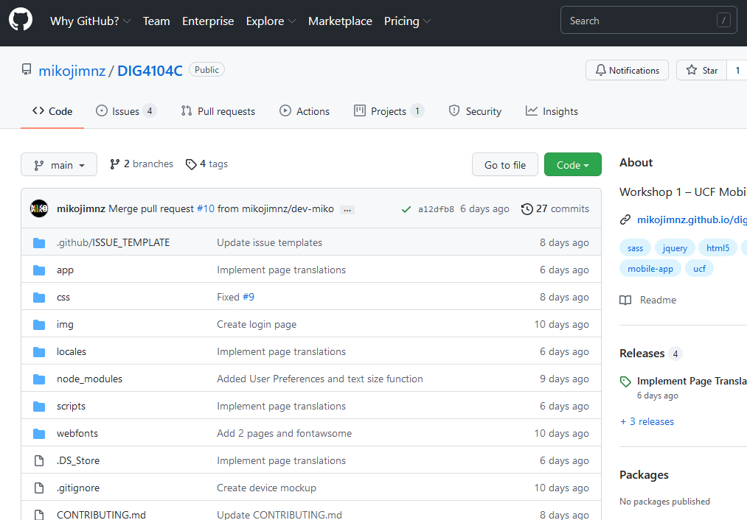

You will need to have an account with github before you can continue through this training guide.

1. **Copying The Repository**

To maintain organization and allow future developers to work without fear of erasing or destroying the current code we recommend copying the github repository.

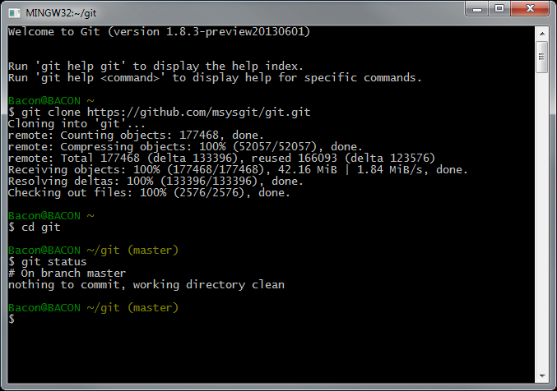

1. Open Gitbash terminal
2. Create a bare clone of the repository.

$ git clone --bare *https://github.com/exampleuser/old-repository.git*

1. Mirror-push to the new repository

$ cd *old-repository*

$ git push --mirror https://github.com/*exampleuser*/*new-repository*.git

1. Remove the temporary local repository you created in step 1.

$ cd ..

$ rm -rf *old-repository*

For more indepth instructions or concerns please refer to GitHub Docs - <https://docs.github.com/en/repositories/creating-and-managing-repositories/duplicating-a-repository>

1. **Updating The Content**

Within your own repository of the code you will be able to edit and update content without affecting the published content on the main github. This is so that there are no accidents regarding deleting working code. You can access the code in each file on github and edit it as you like utilizing, html, css, js, and any other languages that are later added to the application.

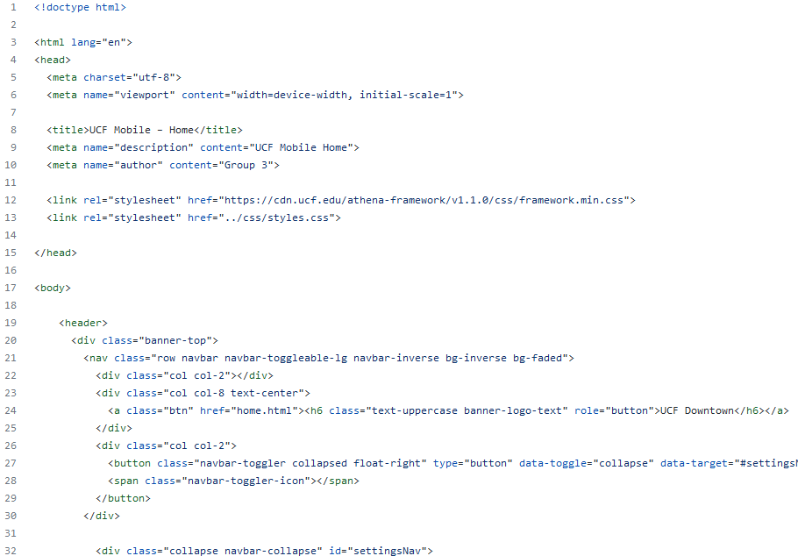

1. **Utilizing the Athena Framework**

The Athena Framework is UCF’s web brand toolkit, which UCF offers a step by step guide as well as information on how to better utilize the framework.- <https://ucf.github.io/Athena-Framework/>

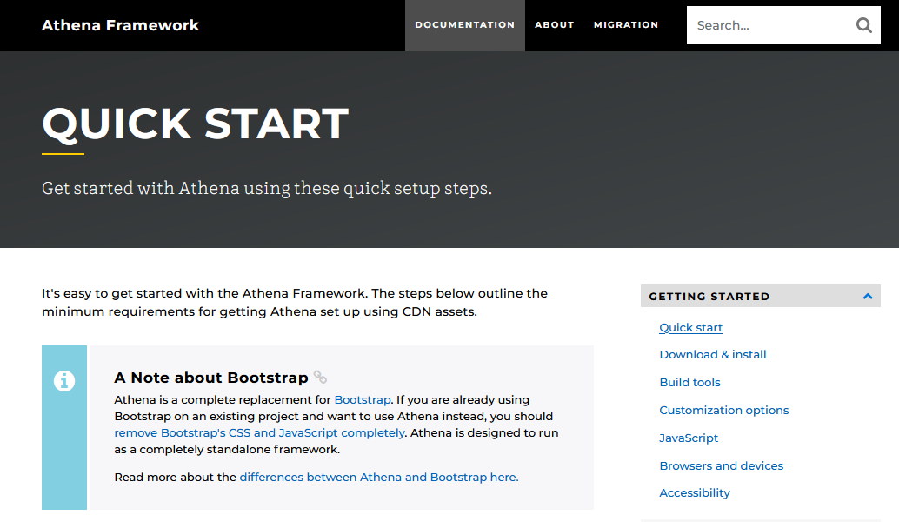

The Athena Framework is based off of [Bootstrap 4](https://getbootstrap.com/docs/4.0/getting-started/introduction/) and should always be considered and referred to when any design changes or new pages are being worked on.

1. **Saving Your Content and Uploading it to Github.**
2. Through your terminal or command line you’ll want to be in the folder where your projects are kept by typing cd/ and the path to that folder.

$ cd /*exampleuser*/*example*

1. Check if git is already initialized: $ git status

# Connect your local project folder to your empty folder/repository on Github.

1. Using the terminal or command line, return back to your project.
2. type git remote add origin [copied web address], this copied web address is the the web address that your local folder will utilize to push the files contents onto github
3. Push your branch to Github: $ git push origin master
4. Double check your github to make sure your Github is up to date and featuring the code you worked on.

**Developer Abilities and Restrictions**

To assist in further development of the UCF Mobile application we have compiled a guide on what abilities and restrictions you may come across when working on the platform.

* **Differences To Be Aware Of...**

Before you delve into the restrictions of each individual page we would like to clarify information. On this application pages refer to the individual page that users can interact with through their mobile devices while posts refer to submitted information such as ‘notification posts’, ‘safety posts’, and other such developer side focused information based updates.

* **Adding Pages and Posts…**

All pages and posts will be implemented and updated through html, css, and js coding.Pages will be hosted on their own individual coding pages while posts may be included in the pages that relate to their category. I.e, notification posts may be put within the notification page.

* **Adding Media And Other Assets…**

As mentioned previously in this training guide, all media and assets will need approval from UCF and will need to follow [UCF’s Brand Assets Guide](https://www.ucf.edu/brand/brand-assets/logo-identity-system/) - <https://www.ucf.edu/brand/brand-assets/logo-identity-system/>. You will be adding any media and other assets through html, css, and js coding.

**Login Page**

**Should not change | Can be restylized**

The function of the login page is crucial to our application and should only be worked on if there are bugs, stylization changes, or new information is required such as captchas or updated login requirements.

**Create an Account**

**Should not change | Can be restylized**

The function of creating an account page is crucial to our application and should only be worked on / changed if there are bugs, stylization changes, or new information is required such as captchas or updated account creation requirements.

**Forgot Account / Password**

**Should not change | Can be restylized**

The function of the forgot account/[password page is crucial to our application and should only be worked on / changed if there are bugs, stylization changes, or new information is required such as captchas or updated requirements.

**Profile**

**Should not change | Can be restylized**

All listed information under the profile page is inputted by the user and required, this should never be changed or removed unless more information is required by the University. However, stylization of the page can be changed.

**Home Page**

**Can be changed | Can be restylized**

The home page is our landing page for our users and can be updated and changed as needed. Any notification changes should be done under the notification page and not on the home page unless the changes are for styling purposes.

**Academics**

**Can be changed | Can be restylized**

The Academics page hosts links and information related to UCF Academics such as Grades, Classes, and links to MyUCF, Webcourses, and Knights Email. This page can be adjusted to the developers discretion but should always keep the four categories listed below.

* MyUCF
  + - A link to the MyUCF app
* Knights Email
  + - A link to the Knights Email portal app
* Grades
  + - Students current grades
* Classes
  + - Students current classes
* Holds and To Dos
  + - Lists of holds and to do’s

**Transportation and Maps**

**Can be changed | Can be restylized**

At launch, our transportation and maps feature will be simplistic as we plan to further develop this feature in future updates. Things that should not be changed is the focus on Downtown Campus. However, the information on campus locations can and should be updated as the campus grows.

**Dining, Amenities, and Housing**

**Can be changed | Can be restylized**

Our DAH (Dining, Amenities, and Housing) page hosts important information for students and staff. This can be restylized or changed though the information that is currently there should not be removed outright, only updated.

Pages that can be altered but should retain its current features and content but can be updated or restylized.

* Dining
* Amenities
* Housing

**News and Events**

**Can be changed | Can be restylized**

This should be updated frequently to better inform our users of events and news regarding campus and UCF related content.

**Safety and Information**

**Can be changed | Can be restylized**

Like News and Events, on the developer side, this should be edited frequently to provide our users with the most recent safety updates and information.

**Notifications**

**Can be changed | Can be restylized**

The host of all notifications, this page organizes all notifications by unread, events, and all. This should be changed and edited for every upcoming update.

**Setting and Preferences**

**Can be changed | Can be restylized**

Setting and Preferences hosts a large amount of user adjustable content and is of critical importance to our users. It is important that all current features remain but certain features can be updated, adjusted, or expanded upon as the app progresses.

Pages that can be altered but should retain its current features

* Change Campus **.**
* Location and Notification Preferences
* Language and Accessibility Preferences

Pages that should not be altered

* Edit Favorites
* Logout

**Profile**

**Can be changed | Can be restylized**

This page hosts user preferences and information, while the content entered by the user should never be altered by developers, the stylization and content can be adjusted to better suit the app in the future.

**Favorites**

**Cannot change | Can be restylized**

As this feature is customizable by the user for their customized experience, there is no further development needed to this part of the application outside of styling changes in the future.

**Quick Links**

**Can be changed | Can be restylized**

Each unique page hosts a list of quick links at the bottom of the page, these can be adjusted to the developers standard but must be cohesive and similar to all quick link sections for pages across the app.

**A Note From Our Developer**

The app is a hybrid app designed and written on top of UCF's Athena Framework, a fork of Bootstrap, which utilizes jQuery and Tether to handle events and core animations. To incorporate accessibility features, the app uses a javascript framework for local language translations and built-in CSS classes from Athena to implement resizable text and dark mode capabilities.